\* df -h refers to the human readable format of disk space

\* awk '{print $5}' - prints 5th word of each line

\* sort -n uses number to sort

\* tail -n 1 -print last value

\* sed 's/%//' - used to replace value so here '%' is removed

df -h awk '{print $5}' | sort -n tail -n 1 | sed 's/%//'

The above command will return the used storage

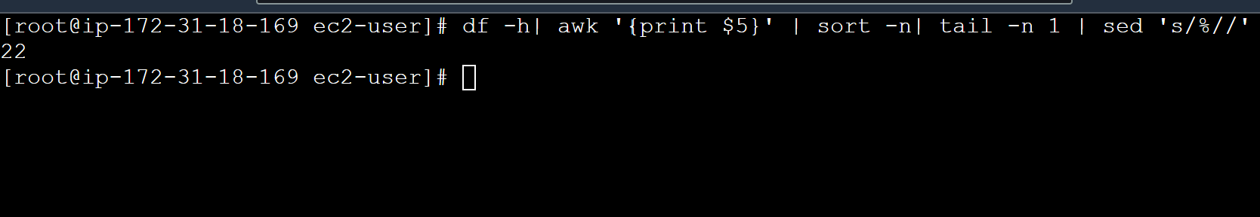

\* As per the above assignment case is used so that statement will be returned based on the number